Virtual Background

Zoom’s virtual background feature allows you to display an image or video as your background during a Zoom Meeting. You can upload your own images or videos as a virtual background. There are no size restrictions when adding your own virtual backgrounds, but we recommend cropping the image to match the aspect ratio of your camera before uploading it.

Enabling Virtual Background
In order to use the virtual background feature you will first need to enable it via the Zoom Web portal.
To enable the Virtual Background feature:
- Sign in to the Zoom web portal as an administrator with permission to edit Account settings, and click Account Settings.
- Navigate to the Virtual Background option on the Meeting tab and verify that the setting is enabled.
Note: If the setting is disabled, click the Status toggle to enable it. If a verification dialog displays, choose Turn On to verify the change.
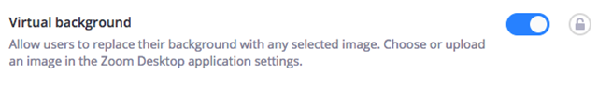

Using Virtual Background
- Sign in to the Zoom desktop client.
- Click your profile picture then click Settings.
- Select Virtual Background.
Note: If you do not have the Virtual Background tab and you have enabled it on the web portal, sign out of the Zoom Desktop Client and sign in again.
- Check I have a green screen if you have a physical green screen set up. You can then click on your video to select the correct color for the green screen.
- Click on an image to select the desired virtual background or add your own image by clicking + and choosing if you want to upload an image or a video.
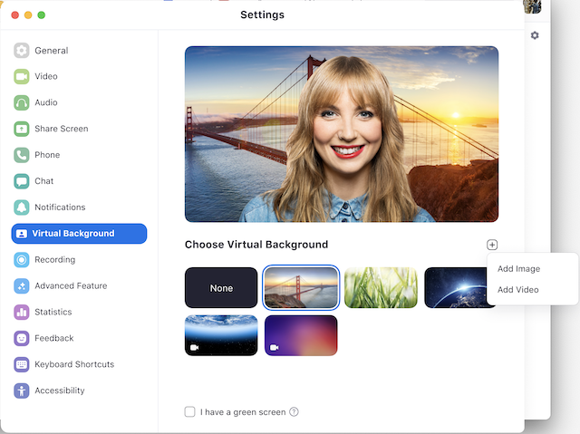
If prompted, click Download to download the package for virtual background without a green screen.
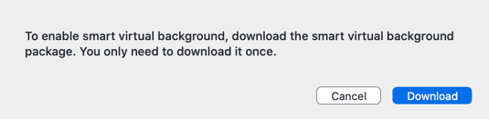
Notes:
  - Ensure that you are using a solid background color.
  - After you select an option, that virtual background will display during your meetings.
  - To disable Virtual Background, choose the option None.

For iOS Users:
- Log in to the Zoom mobile app.
- While in a Zoom meeting, tap the More button in the bottom right hand side of the controls.
- Tap Virtual Background.
- Tap the background you would like to apply or tap + to upload a new image. The background will be automatically applied.
- Tap Close after selecting the background to return to the meeting.
- To disable Virtual Background, open the virtual background options again and choose the option None.

Troubleshooting
If you are experiencing issues with Virtual Background, try the following troubleshooting tips:
- If you do not have the Virtual Background tab in your Desktop Client settings after enabling it, sign out of the client and sign in again.
- Manually pick the background color to ensure the correct color is selected. This option is only available after you click an image.
- Ensure that the background is a solid color with minimal shadows. Also ensure the background is uniform in lighting. A 3 point lighting setup is ideal.
- Ensure that your green screen color does not match your shirt or eye color.

